**iSMA-B-LP / iSMA-B-LP-1**

|  |  |  |  |
| --- | --- | --- | --- |
|  | **iSMA-B-LP** is a **wall panel with 2.3” LCD display** and four function buttons. Additionally, the panel has the built-in temperature sensor and optionally the humidity and CO2 sensors. iSMA-B-LP is powered with 24 V AC/DC and has the built-in RS485 port (**Modbus RTU/ASCII, BACnet MSTP**). Use of open communication protocol allows to connect the panel with any controller supporting **Modbus RTU/ASCII** or **BACnet MSTP.** Together with iSMA-B-FCU controller, the panel allows to change the basic parameters such as: temperature setpoint, fan speed, FCU mode and others. Thanks to built-in USB port, there is possibility to maintenance the panel configuration without the power supply. iSMA-B-LP has the modern design and **it is available in different colours** at client’s request, and also **in two versions of button icons** **appearance.** | Key Features  * 2.3” LCD display with backlight * 4x function buttons * Built-in temperature, CO2 and humidity sensors * Modbus RTU/ASCII * BACnet MSTP * Wall mounting (standard electric box – 60 mm/2.3622 in) * Changing of the basic parameters in conjunction with FCU controller * 2x RJ12 for fast connection to FCU controller * 7 main menu categories * Over 100 freely configurable variables * Possibility to display the current time |  |

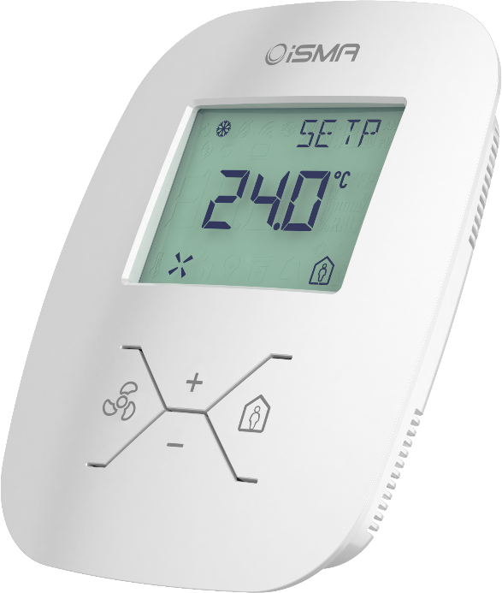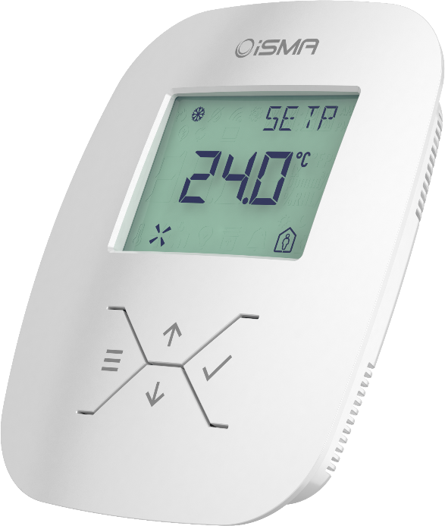

**iSMA-B-LP-1**

**iSMA-B-LP**

|  |  |  |  |
| --- | --- | --- | --- |
| Temperature sensor:   * Type: 10k NTC * Range: 0 – 50°C (32°F – 122°F) * Accuracy: +/- 0,5°C (0,9°F) * Resolution: +/- 0,1°C (0,18°F)   Humidity sensor**:**   * Range: 0-100% RH * Accuracy: +/- 2% RH in range 20 – 80% RH * Resolution: +/- 1% RH   CO2 sensor**:**   * Method Non Dispersive Infrared (NDIR), gold plated optics, diffusion sampling (with Telaire’s Patented ABC Logic Self Calibrated Algorithm) * Range: 400 – 2000 ppm * Accuracy: +/- 30 ppm OR +/- 3% of reading * Stability: < 2% of FS over life of sensor (15 years typical) * Warm Up Time : < 2 minutes (operational); 10 minutes (maximum accuracy) * Calibration: ABC Logic Algorithm * Manual Calibration Interval: Not required | | Communication   * 2x RJ12 terminal (RS485 half-duplex) * Baud rate: 2400 to 115200 bps * Protocols: Modbus, BACnet * MINI USB, Type B   Platform   * ARM Cortex: M0+   Housing   * Dimension: 100x123x27 mm (3.9371x4.8426x1.063 in) * Construction: plastic, self-extinguishing (PC/ABS) * Wall mounting (standard electric box) * Cooling: internal air circulation   Environment   * Operating temperature: 0°C to 50°C (32°F to 122°F) * Storage temperature: -40°C to 85°C (-40°F to 185°F) * Relative humidity: 5% to 95%, no condensation * Ingress Protection Rating: IP20 * For indoor installation   Power supply   * 24 V AC/DC +/- 20% | |
| **Type** | **Temperature** | **Humidity** | **CO2** |
| **iSMA-B-LP(-1)** | **√** |  |  |
| **iSMA-B-LP-H(-1)** | **√** | **√** |  |
| **iSMA-B-LP-C(-1)** | **√** |  | **√** |
| **iSMA-B-LP-HC(-1)** | **√** | **√** | **√** |

